**Institute of Technology Tralee**

**BSc. in Computing with Specialism (Group 4) - Year 1**

**Continuous Assessment #2**

**Date: 10/12/14**

**Time: 3 – 5 p.m.**

**Introduction to Programming**

**Instructions:** Attempt the following question. You should use the JCreator IDE for coding. When you are finished you must print out your code for correction.

**________________________________________________________**

**Q1.**

A program is required that will first of all prompt for and read in a user-supplied piece of text. Then a set of menu options will appear giving the user a list of different ways in which they can process the piece of text that has been entered as follows:

1. Display the number of characters in the piece of text
2. Display the first and last character in the piece of text
3. Display the number of times lowercase ‘d’ appears in the text
4. Determine if the sequence of characters “ing” appears in the text

Note for option D. that you will need to examine 3 consecutive characters at a time to determine whether the sequence of characters ‘i’, ‘n and ‘g’ occurs.

Once the user enters their choice, the program will carry out the required set of actions as indicated.

You can use **while** loops for all iterations required in the program, but you should try to use a **switch** in order to decide which course of action will be taken based on the options A-D above.

Using the test values as indicated in the screen shots below, the program should give you **exactly** the following output when it runs, including any banners, blank lines, tabs etc.

Also note that there will be a few marks awarded for having a **single-line comment** and **a meaningful multi-line comment at the top of the program**.

**Sample Screen Shots**

**Run 1 – A piece of text is entered, the menu option appears, choice A is selected and the number of characters in the text is displayed**

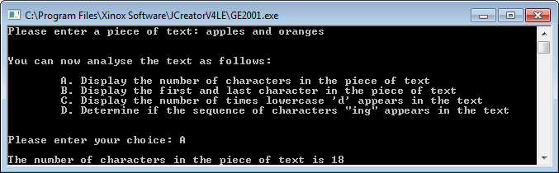

**Run 2 – The text is entered, the menu options display, choice B is selected and the first and last characters in the text are displayed**

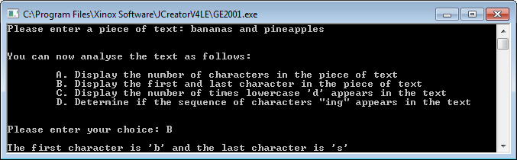

**Run 3 – The text is entered, the menu options display, choice C is selected and the number of lowercase ‘d’ characters is displayed**

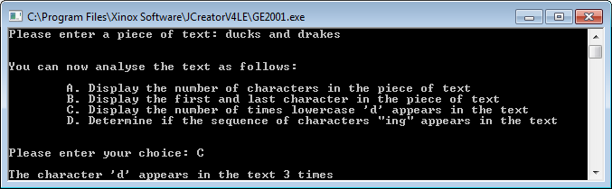

**Run 4 – The text is entered, the menu options display, choice D is selected and a check is performed to see if the sequence of characters “ing” appears in the text (yes in this case)**

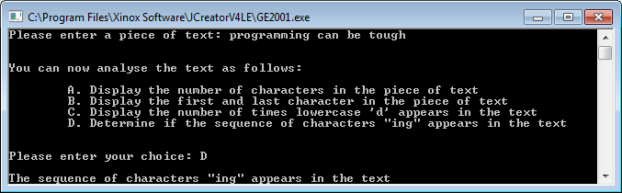

**Run 5 – The text is entered, the menu options display, choice D is selected and a check is performed to see if the sequence of characters “ing” appears in the text (no in this case)**

